Proposed Structure:

* CS_montecarlo
  + data/
    - loaders.py
    - preprocess.py
    - resample.py
    - returns.py
  + models/
    - asset_simulation
    - portfolio_simulation
    - monte_carlo
  + analysis/
  + strategies/
  + backtest/
  + dashboard/
  + utils/
  + main.py
  + README.md

General SRC structure:

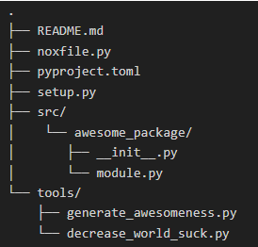

Keep in mind:

* Scalable and **modular**
* Readable
* Decouple elemets and utils (such as visualization)
  + Single Responsibility

Readability:

* Avoid excessive nesting (use inversion – inner logic placed after and outside conditions, rather than within)
* Extraction – move large blocks of code out of logic flows and into functions. I.e. don’t obscure top-level functionality with low-level code
* Avoid code duplication